

Emmaus Lutheran Church
1224 Laurel Street
Indianapolis, IN 46203
Semi-Annual Parish Meeting
June 7, 2026

38 people in attendance

Meeting opened with prayer

Treasure Report
INCOME:
Unified Budget $203,680.00
EXPENSES:
Bank Fees $3,416.00
Church Office, Maintenance , Supplies & Altar$7,490.00
Insurance & Workman's Comp $19,500.00
LCMS Obligations $4,900.00
Maintence $7,420.00
Property Taxes $1,300.00
Salaries & Benefits $198,967.00
Technology $3,240.00
Utilities $28,342.00
TOTAL EXPENSES: $274,575.00
NET SURPLUS/DEFICIT: ($70,895.00)

NOTES:
1 Paychex Quick Booksm Safety Deposit, Vanco
2 CCLI, CM Almy, Concordia Publications
Imperial Dade, Misc Office Supplies, Toshiba
3 Guide One, Menonite Mutual
4 Indiana District, Lutheran High School
5 Chardon, Dilling Group, Korsen, Snow Removal
Total Extermination
6 Pastor, Church & Financial Secretaries, *
Custodian, Organist
7 Google Nest, Wix
8 AES, ATT, Citizen's Energy, Marion County
Storm Water, Republic, Ring Central
* Secretarial payments are estimated high

Derek Roesener made the motion to approve
Gary Strakis 2nd the motion
All present voted yay

Tim stated that we have 26K in checking. All bills are paid and in the black. We have 150K in endowment investments. $150k in LCEF liquid funds and we were just blessed with a $35K donation.

Call Committee
Pastor Gramzow will mail call documents for acknowledging call receipt and acceptance TBA
Pastor study has a new telephone and a desktop computer.
Gary Strakis and Bob Stevens have refinished the desk in Pastor’s study.
Pastor Gramzow visited on May 24th.
Plans are being made for the Installation. Date still being worked on.
Pastor Gramzow will be installed on August 1st at 10am and will his first service will be August 2nd.
Installation of Pastor James Gramzow
Facility Board Report
Recent Activities
Clean Up Day in May (Thanks to everyone for their time and effort to maintain our facilities)
Glass replaced in Gym door and 15 windows with broken seals and damages
Boilers shutdown for the season
Secure 1903 school pass door next to school office
Preparing Pastor’s office for his arrival in July
Jeff built new rack in preschool room for storing church banners
To Do Major activities
125 year celebration considerations:
David Kieser (Kieser Consulting Group, LLC) Restoration planning:
Tuckpoint brick and parapets and gutter system repairs
Roof repairs
Cement, steps and handrail repair at Laurel St sanctuary entrances
HVAC and Boiler replacement in sanctuary basement
List is not conclusive
Endowment considerations:
Consideration of replacing Sanctuary carpet
Sanctuary Boiler repairs
Backflow and pressure valve replacement
Power supply cutover for circulating motor primary/backup
Replace Sight tube for water level
Actuator/Valve repair
To Do minor activities
Pantry quote considerations: Brick and mortar repair,Roof/gutter repairs
Refinish floors for gym, café, and kitchen (Jake)
Paint Laurel St entrance (Jake)
Continue to monitor broken/shifted sewer drain – located near gym entrance
Repair Vent fan over kitchen oven/stove

Elder Semi-annual Report
Since the January 18 semi-annual meeting to present, the Elders have continued to review the needs of the congregation and bring Communion to shut-ins.
The conference room gets cold in the winter for Bible classes and meetings. It was decided that the most economical way to solve this problem was to get a good space heater. Gary took care of the problem by buying two portable heaters.
Security issues were discussed and it was decided to lock the 1904 school building & the 2nd floor of the 1982 school when not in use. Gary took care of this by installing a padlock on the door to the .
Pastor Irmer indicated that Emmaus should have some additional liturgical supplies (for Emmaus and for use by fill-in pastors) Tim is looking into and taking care of this.
Pastor Gramzow and Pastor Mierow will coordinate the Installation Service.
Following are the changes in the congregation since the January 18 semi-annual meeting to present:
Baptisms (1): Margaret June Fletcher
Deaths (3): Helen O’Conner (Jan 12)
Katherine Arritt ( April 28)
Agathe Hildebrandt (May 19)
Transfers In (3): Ellwyn Parks
Joel & Robin Westphal

Endowment Report
We had a lot of receipts this year. The George family and O’Connor family donated for use of the Food Pantry.
We helped fund the electrical box in the basement and at the pantry and with the boiler repair.
We are looking at new roofing and tuck pointing for the church.
We invested 150K for the unified budget.
Jerry Roesener has agreed to continue as the chairman for the next 3 years. Tim Birtchman made the motion to accept this and Pat O’Connor 2nd the motion. All were in favor.

Pantry Report
In the last 3 months we have served 4082 people and 403 families in 38 days.
The treasurer has caught up on all donations given to the pantry.
The George family gave 15K to the endowment for repairs.
Gleaners rep came to visit the pantry and was very pleased at how organized and clean it was.
Our monthly expenses are rising.
Thank you all for your continued support and donations. We are very blessed to receive donations from other vendors and churches around the city.

Board of Fellowship
We continue to have monthly meals.
We were able to gather on Wednesday’s during Lent and had Easter breakfast.
We welcomed Robin Westphal to our group.
Thank you dinner for Pastor Irmer will be on July 26th

Outreach Board
Current members of the Outreach Board are Sandy Duncan, Robert Carey, Tresa Strakis, JoAnn Riemer, Karla Frownfelter, Elwyn Parks, Kenny Colton, and Sherry Jett. We all mourn the loss of board member and dear friend Katie Arritt, who passed away into the arms of Jesus during surgery on April 28. Her funeral took place on Saturday, May 16.
The PANTRY is an important part of our board, and Robert gives us an update on it at each of our meetings. That report is on a separate sheet.

We have discussed the possibility of the Outreach Board handling FUNERAL TREATS. This had come up as a result of Elwyn’s request/suggestion to JoAnn on the Sunday following Helen O’Connor’s funeral. He and Pat O’Connor had done coffee and donuts for the family during the visitation before Helen’s service. The results of our discussion were that we would put Elwyn in charge of notifying a board member. Then he can do the coffee (since he’s there anyway) and the board member will provide the treats.

We want to have some VISITOR GIFT BAGS on hand to give to first time visitors and develop a system for giving them out. We have decided to put an Emmaus pen, an Emmaus cup/mug, a small flyer about the church, and perhaps a seasonal devotion in the bag. We’ll probably ask our new pastor, Pastor Gramzow, if he has any other ideas for this before we start.

Our board did the LENTEN DINNER which took place on Wednesday, March 4. We served a pulled pork dinner with tasty side dishes and dessert. The dinner went really well with an attendance of about 25 or so. The free will offering taken in was $90. This was added to the monies that could be spent for the Easter Egg Hunt.

This year’s EASTER EGG HUNT took place on Saturday, March 28, 2026, at 11 a.m. Families were registered as they arrived on family registration sheets and the children signed up for the Egg Hunt by four different age levels. Children were also given bags to collect their crafts and the eggs from the hunt. We had a continental breakfast of cinnamon rolls, breakfast pizza, fresh fruit, fruit juice, milk, and coffee. We also had three different crafts available, as well as a game with some prizes and cookie decorating. These activities helped to entertain the children until the time came for their egg hunts.
The four egg hunts were run by Kairi Aldrich, Abbey Smallwood, and Grayson Hurst placing the eggs in various outdoor areas. The outside temperature was rather cool for our hunt this year (in the low 50’s and dry), but all four coat-clad age groups were beaming when they came through the door after gathering lots of eggs. An additional event this year was a contest to see who could guess how much candy was in three plastic bunnies. Three lucky winners got to take home the bunnies full of wrapped Easter candy!
There were 29 children who signed in for the various egg hunts, out of a total of 68 registered guests. In addition to these guests, we had 22 helpers—(6 of them were Thrivent members), making for a total of 90 people that we fed. There were baked cinnamon rolls, fruit juices, and some of each cut fruit leftover. All of this was put to good use for future meals, etc. The helpers were volunteers from the church. Many volunteer hours go into this event, and it is well received by the community.
In preparation for this event, congregational members donated the candy for the plastic eggs. The eggs themselves were donated by members when purchased after Easter at a discount in past years. To prepare the eggs for this year’s hunt, a group of 17 volunteers met on Wednesday, March 25 to fill the eggs with the donated candy.
We received Thrivent funding of $250 for this event. We also had available to use $237 in free will offering monies and donations from various dinners that we could spend to help fund this event. The cinnamon rolls, breakfast pizza, and prizes for our game were donated by our Pantry for use at this event. Since we had all these sources, Emmaus Lutheran Church incurred no debt to put on the Egg Hunt. How the funds were spent are listed on a separate sheet and available upon request.
Our board continues to sponsor the popular after church SUNDAY TREATS with our board members taking turns bringing the treats. Please come join us in the gym after church to visit and enjoy Christian fellowship! Also, other members of the congregation are very welcome to volunteer to bring the treats any Sunday. Remember, they don’t have to be home-baked; store-bought are just fine!
We are pleased to announce our upcoming events. The first thing we are planning is a “FAM JAM” which is scheduled for Saturday, June 27 at 3 p.m. This is basically a family (2-3 hour) VBS, which will include a short Bible story, 1 craft, 1 game, 1 song, and a light meal like pizza, with drinks, and cookies or ice cream cones. We plan to use the story of David and Goliath. We plan to mail invites to the egg hunt families and do other types of publicity. Please pray for the success of this new event.
Other upcoming events for the Outreach Board will be a Summer Cookout (Date to be determined-perhaps in August), Octoberfest (Probably Friday, Sept. 25), and Everybody’s Birthday Party (Date?).

Meeting was closed by singing the Doxology

Respectfully submitted,
Carol Chandler

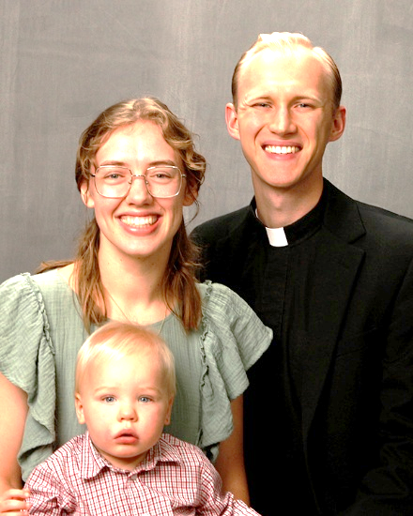
Installation of Pastor James Gramzow

With joy and thanksgiving, Emmaus Lutheran Church announces the Installation of Pastor James Gramzow on Saturday, August 1, 2026, at 10:00 a.m.
The congregation is invited to gather for this special service as Pastor Gramzow is formally installed to serve among us in Word and Sacrament ministry.
There will be a reception following the service.

Outreach News

The Outreach Board is sponsoring our first ever “FAM JAM” on Saturday, August 15 at 3 p.m. This is a family mini-VBS featuring the Bible story of David and Goliath. The Theme for Fam Jam is “With God You Can Slay Giants!” At this Thrivent event, we will be passing out some free back-to-school supplies. In addition to hearing the story, there will be songs, games, and a craft that the families will be involved with. After refreshments, we are passing out prizes to all who came. Spread the word to your friends and family, and there will be sign-up sheets available soon for some helpers.

The Outreach Board continues to serve the popular SUNDAY MORNING TREATS every week in the gym as parishioners gather to visit and share a cup of coffee and a goodie or two. We want to invite more of you to join us in this pleasant time. Also, if you would like to bring the treats some Sunday, just let JoAnn Riemer know.


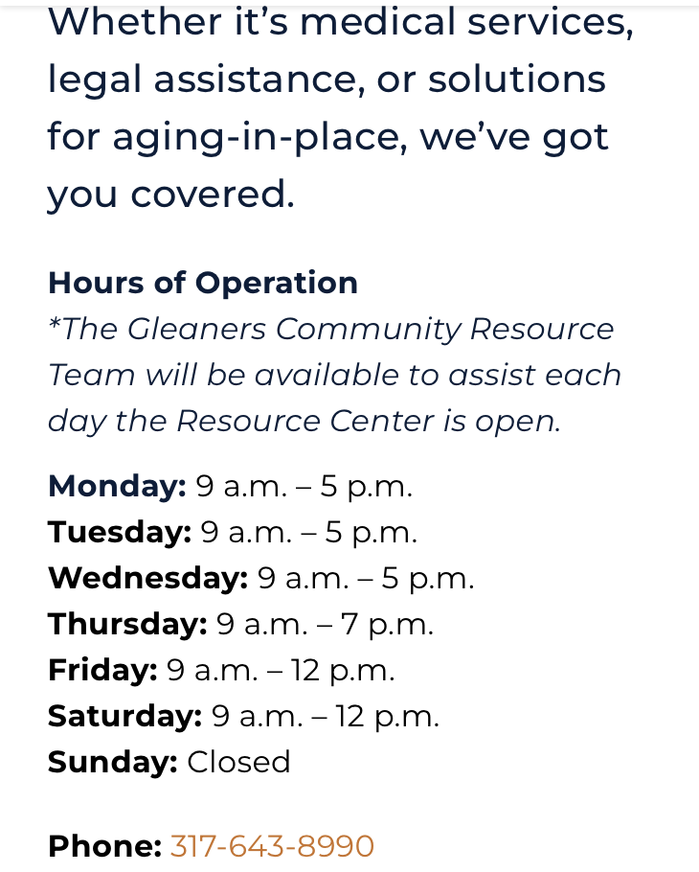
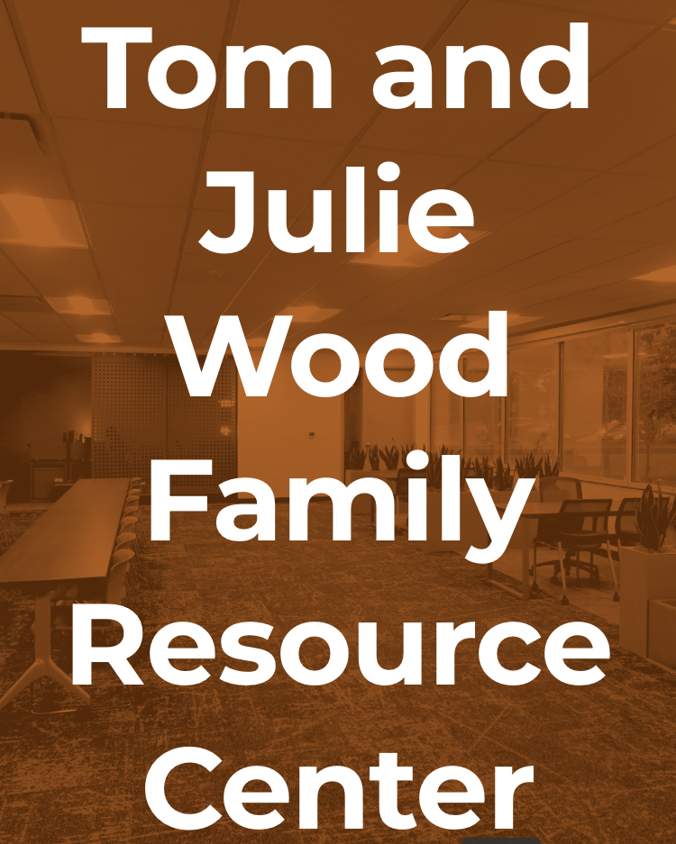
PARISH PLANNING MEETINGS are held the 2nd Tuesday of every month (August 11) at 6pm. The business of the church is conducted at these meetings and any church member is welcome to attend, to ask questions, express concerns, make comments, ect. Please let the Church office know the day before that you will be attending.
Monthly Game Night
The Pastor Smith Game Nights are now on Saturday at 4:00pm. We will meet on July 11th and August 8th. Bring a snack to share and we will see you there!!!!


CONTACT INFORMATION
Phone: 317-632-1486
Fax: 317-632-2620

Emails:
emmausindy@gmail.com (general)
emmauschurchindy@gmail.com (church)
Website: elcindy.org

Adult Sunday School

We meet every Sunday at 8:45am in the conference room during the Sunday School hour. Come join our group led by Robert Carey from 8:45am-9:45am
Senior’s Bible Study Class
Wednesday mornings @ 9:30 a.m. We look forward to our new study. Now would be a great time to join us. Anyone who is free on Wednesday at that time would be welcome to join our lively discussion as we learn more about our Christian walk with Jesus. Norm Riemer is the leader of this group.

ELDER MEMBERS
Members in need of ministry care or with
spiritual concerns should call one of the
Elders:
Tim Birtchman 317-788-0021
Dave Duncan 317-783-3726
Scotty Jett 317-490-9742
Norm Riemer 317-862-4344
Jeff Frownfelter 812-929-2495
Gary Strakis 317-332-0937

Emmaus Pantry News
Your Emmaus Food Pantry blessed 316 households representing 1,247 individuals over 11 days in May thanks to your generosity and our loyal volunteers. Lower monthly government allotments pushed our food purchases from $679.77 to $890.28 to $1,049.69 the last three months even though Gleaners provides fresh produce and milk at no cost to us and our regular individual, church and corporate donors continue to provide regularly. Utilities average $300 monthly.
Gleaners reported that in 2025 one in six children in central Indiana is food insecure The reduction in SNAP benefits for 2026 is creating more hardship that affect mostly children and Senior citizens. They also boast that 69% of the foods they distribute are nutritious.
Calvary donated $1,220 from the proceeds of their garage sale besides their monthly food donations. Thanks to Lori and Ellwyn and those of you who leave items in the wagon for your food donations as the shelves empty faster each month. We continue to receive monetary donations from members and former members which make the treasurer’s job easier
Summer food donations generally decrease, but children are home from school and family allotments that helped last summer were eliminated in Indiana this year. Thank you for your continued prayers and support. Look for our volunteer opportunities in July and August on Gleaner days.






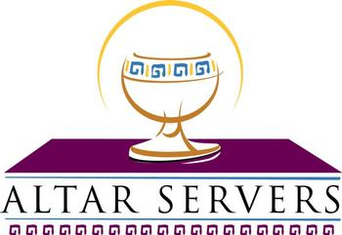
JULY 2026 SCHEDULE

7/5 Jeff Frownfelter 7/5 Dave Duncan
7/12 Gary Strakis 7/12 Norm Riemer
7/19 Tim Birtchman 7/19 Garald Evans
7/26 Bob Groth 7/26 Jerry Campbell
7/5 Andrea Campbell 7/5 Jerry Roesener
7/12 Norm Riemer 7/12 Carol Chandler
7/19 Pat O’Connor 7/19 Kathy Rogers 7/26 Bob Groth 7/26 Bob Groth

7/5 Whitsit/Herndon
Frownfelter 7/12 Cantwell/B. Smith
7/19 Jeff & Karla Frownfelter
7/26 Norm & JoAnn Riemer
July Birthdays

Jonah Chumley 7/6 Patricia Klinge 7/15
Kathy Rogers 7/6 Gary Sater 7/15
Grayson Hurst 7/12 Lisa Lee 7/18


AUGUST 2026 SCHEDULE
8/2 Jeff Frownfelter 8/2 Dave Duncan
8/9 Gary Strakis 8/9 Norm Riemer
8/16 Tim Birtchman 8/16 Garald Evans
8/23 Bob Groth 8/23 Jerry Campbell
8/30 Jeff Frownfelter 8/30 Dave Duncan

8/2 Tim Birtchman 8/2 Horst Hildebrandt
8/9 Andrea Campbell 8/9 Jerry Roesener
8/16 Norm Riemer 8/16 Carol Chandler
8/23 Bob Groth 8/23 Bob Groth
8/30 Pat O’Connor 8/30 Kathy Rogers

8/2 Betty Whitsit/D Herndon
Cantwell 8/9 Cantwell/B Smith 8/16 Jeff & Karla Frownfelter
8/23 Norm & JoAnn Riemer
8/30 Whitsit/Herndon
August Birthdays

Derek Roesener 8/12 Bonnie Smith 8/13 Jonathon Hurst 8/13 Pat O’Connor 8/19

