Emmaus Lutheran Church
1224 Laurel Street
Indianapolis, IN 46203

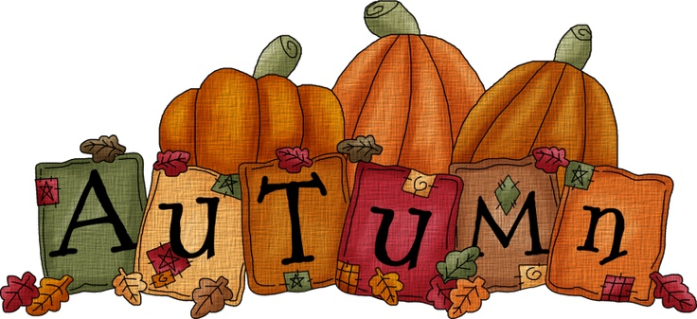

September/October 2026
The Emmaus Companion
Bi-Monthly Newsletter

Greetings and Blessings

Dearly Beloved Saints of Emmaus -

The Lord be with you!

These words are perhaps most familiar to us from the part of the liturgy known as the “Salutation”.

They are, of course, a greeting. They invoke the words of the Archangel Gabriel to Mary, “Greetings, O favored one, the Lord is with you!” (Luke 1:28).

However, the salutation is more than just a greeting.

It’s not a holy “hi how are ya”
“back atcha bud”

It’s a blessing that I speak over you, announcing that the Lord is with you, through the Word of God which is about to be heard in the readings and proclaimed in the sermon. I speak the same blessing over you when we begin the service of the Sacrament, acknowledging that the Lord is with you with His holy Body and precious Blood we are about to receive in the Lord’s Supper.

Your response, “And with thy Spirit”, refers to how the Lord is coming among you; namely, by the power of the Holy Spirit working through the Office of the Holy Ministry in the distribution of Christ’s gifts in Word and Sacrament.

It’s a quick double prayer.
I’m giving you a blessing, praying that the Lord would be among you with His gifts, and you respond by praying that the Holy Spirit would rest upon me, since I’m about to speak to and work among you as the bearer of the Office of the Holy Spirit.

And it’s not just a formality or a churchly nicety either. As your pastor, I’m in need of grace and your prayers, that I would be faithful in carrying out my duty to fitly speak and rightly teach you all things as coming from God, as His faithful ambassador to you.

With this quick exchange I’m making good on my installation vow to you to be constant in prayer for all of you whom the Lord has put into my pastoral care, and you likewise make good on your promise to pray for me always.

So it is always that my prayer for you, dearly beloved, is that the Lord would be with you. So also, there are few words that could be more encouraging for me to hear from you than, “And with thy Spirit.”


Ever,

Pastor Gramzow

What are all these things the Pastor wears?
In the Old Testament God commanded that Israel’s priests were to wear special garments when they served in the Tabernacle, and later in the Temple (Exodus 28:1; 39:4). This Divine command carried on, but was fulfilled by Christ at His death. When He died, He fulfilled the entire system of Old Testament sacrifice and worship. Though He instituted no command of what His Church’s ministers are to wear in the Divine Service, reverence has caused the Christian Church to adopt a certain type of dress for her ministers in the Divine Service.
In the Reformation, Martin Luther did not abolish the system of vestments (the garments worn by the minister and his assistants in the Divine Service) used by the Roman Catholic Church. Instead, he wrote to German Pastors, “We have passed over the matter of vestments. But we think about these as we do about other forms. We permit them to be used in freedom.” (AE 53:31, An Order of Mass and Communion for the Church at Wittenberg). Similarly, the Apology of the Augsburg Confession states: “We also keep traditional liturgical forms, such as the order of readings, prayers, vestments, and other similar things” (Ap XXIV 1). Historically, the Lutheran Church never left behind the vestments adopted by the Church through the centuries. Though styles change and vestments have taken different appearances through the ages, the idea has remained the same.
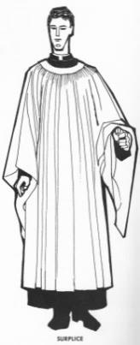
The basic garment of the Pastor is the cassock. The cassock is the foundational garment over which all the other vestments are worn. It is a close-fitting black robe that buttons down the center. For a non-Communion service, the Pastor wears a surplice over the cassock. The surplice is a flowing white vestment that is slightly shorter than the cassock. It has large sleeves which may extend to the hand at the top and to the ankle at the bottom. However, the cassock and surplice are not reserved for Pastors only; the cassock and surplice are also worn by all those assisting in the service (acolytes, servers, etc.)
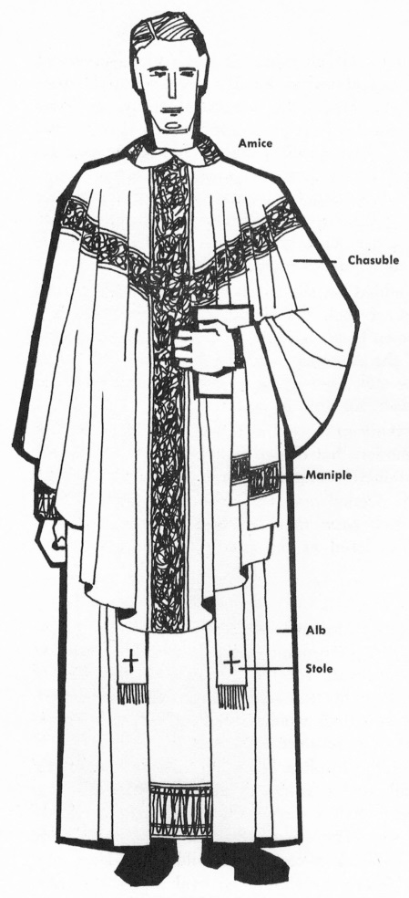
For Communion services, the Pastor wears a more elaborate system of vestments. The cassock still serves as the foundational garment. The next thing put on is the amice. The amice is a rectangular piece of linen worn around the neck to protect costly vestments from damage due to sweat and skin oils. The alb comes next. The alb is a white garment that covers the cassock completely. Around the waist is tied a cincture. The cincture is often a white rope. It primarily helps adjust the length of the cassock and alb, should they be too long.
Over these base vestments, others that are made in the color of the day in the Church Year are worn. On the left wrist is worn the maniple. Its construction and design are similar to that of the stole, which is worn around the neck. When Pastors put on the stole for the Communion service, they cross it, right over left, symbolizing that they are one under authority, exercising this Office only because Christ has placed them in it. Over all these things is worn the chasuble. If laid on the floor, the chasuble is an oval with a hole cut in the center for the head. The design on the chasuble is typically a cross in a Y shape made of orphreys (bands of elaborate material) that match or complement the color of the chasuble. In the center of each side may be a symbol, called a vesica, which may be any number of Christian symbols that teach us about Our Lord.
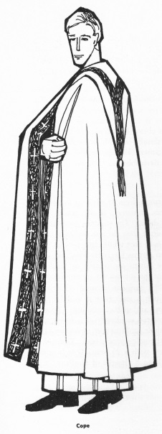
A vestment worn infrequently is called the cope. The cope is a cloak or cape open in the front and attached with a clasp or piece of material called a morse, and has a hood or highly decorated hanging on the back. The cope is worn for festival occasions (high feast days in the Church Year [e.g., Christmas, Easter, Pentecost, etc.], special days in the congregation [e.g., anniversary, Baptism, Confirmation, etc.]), but not only at a Communion service. It may be worn by the Pastor at any type of service. If it is worn in a Communion service, prior to the start of the Communion Liturgy it is replaced by the chasuble.
But what do all of these things mean? For the Eucharistic Vestments there is great symbolism. Much of this can be found in the prayers the Pastor says as he puts them on. The prayer for the amice relates it to the “helmet of salvation” (Ephesians 6:17). The alb’s significance is tied to Baptism. Because it is white we are reminded of the innocence and robe of righteousness Jesus has placed on us at our Baptism. The maniple is reminiscent of the servant’s towel, reminding the Pastor that he is both servant of Christ and the people, bringing to them all that Christ has given him to share. As the Pastor puts on his stole, he prays that the Lord would “restore the stole of immortality which I lost in the transgression of my first parents.” It symbolizes Our Lord’s perfect obedience by which He obtained for us the stole of eternal life (Revelation 7:9). Finally, the chasuble is related to the yoke, or task, Jesus gives to His ministers. The chasuble signifies that the wearer is in the service of Jesus Christ, doing His will and working according to His directions.
But don’t all of these things distract us from Jesus and make us look at the Pastor and all the elaborate things he is wearing? The simple answer is, no. Vestments are designed to cover the man. They are a sign of the Office of the Holy Ministry, the authority from Christ with which the man wearing them is vested. They are something God commanded in the Old Testament. They have been retained in New Testament use and to this day because they confess Christ.
On this, Rev. David Petersen, Pastor of Redeemer Lutheran Church in Fort Wayne, Indiana remarks: “The question if often asked, ‘Why are the vestments so fancy if our intention is to move the attention away from the man?’ The answer is simple: ‘The vestments are “fancy” to draw attention to themselves. They are meant to remind us that we are not in the world in the Divine Service. We leave the world and enter the royal court of the Lord, God Himself is present for us, God Himself speaks, absolves, and feeds us. The men who wear the vestments step in and out of them, utterly replaceable. They are lost, indistinguishable, one from the other, in the vestments. They don't express their personalities, styles, or tastes. They are covered up.”
Though different Pastors may employ more or less vestments, it does not make one right or the other wrong. Throughout her history, the Lutheran Church has seen variations in what is common liturgical apparel for her ministers. The point of vestments is not to make us look at the Pastor, but to teach us more about Christ. Through the various symbols embroidered on the vestments or the meanings each garment has we are taught about Christ. When such an uncommon thing is worn we are reminded that we are in the very presence of Our Lord and special things are worn to confess that nothing ordinary is happening here.
The adornments of the Christian Church confess Christ to us at every turn. The colors with which she adorns her altars, the vestments with which she clothes her ministers, the art with which she embellishes her windows, the objects with which she enriches her walls: these things are not meant primarily to be decorative, though they may be so; they are primarily meant to be instructive.
And the one who knows what they signify and symbolize comes into a church which features them to find himself surrounded on all sides by a host of silent sermons, preached to him in silk and glass, wood and stone.

Parish Planning Meeting Minutes
August 11, 2026

Present - Jeff Frownfelter, Jerry Campbell, Carol Chandler, Pastor Gramzow, Norm & JoAnn Riemer, Robert Carey, Tim Birtchman
Not present- Gary Strakis

Minutes read and approved.

Treasurer Report
All bills are paid and current.
Donations are covering the AC cost.

Elders Report
The Elders (except Dave Duncan- on vacation) had a get acquainted meeting with Pastor James Gramzow and discussed elder topics.
Starting next month, the Elders will change their meeting time (1st Tuesday in the month) from 6:30 to 6:00 PM.
We will be studying the book name “Has American Christianity Failed”

Outreach Report
Robert gave us a brief PANTRY REPORT. They can have 28 maximum clients daily, and yesterday they had 27. It has been a roller coaster ride on donations. The next Gleaners pick up day is Monday, August 10.
We next talked about the things left to do to prep for FAM JAM on August 15. Banners for the fence have been purchased and are now in place. The $250 Thrivent money will be used to shop for the needed supplies. We also have $150.30 in cash that we’re able to spend. The congregation has been very generous in donating school supplies that we can pass out. We will be setting up for our event on Friday the 14th. Also, on that day we will prepare Outreach bags to give to the families which will include information about our church and future events happening here. We have advertised this event to people who come to our Pantry, the children who attend CCA, the community, and we mailed letters to each family who came to our Easter Egg Hunt.
We spent a few minutes discussing OCTOBERFEST. This will be our next event and will take place on Friday, September 25. Karla Frownfelter has agreed to apply for Thrivent money ($250) ASAP. She will co-chair this event with either JoAnn or Tresa (to be decided later).
We made sure we had the next couple of SUNDAY TREATS taken care of and then JoAnn closed our meeting with prayer.

Properties Report
We are looking to replace the Dilling Group (heating/cooling)
We will be using Real Comfort for our service contract.
New AC coil is being made, expected to be here in September.
Gutters need to be cleaned in October.
Look into seal coating the inner lot

Fellowship Report
We have been busy. We served a thank you dinner for Pastor Irmer on July 26th. We are truly thankful for his service.
August started with the reception for our new Pastor. We welcomed Pastor Gramzow on 8/1/26.
We are making plans for upcoming dinners, and believe it or now, Christmas Breakfast
Pantry Report
Your Emmaus Food Pantry served 1,505 hungry individuals from 384 homes over 14 days in July. Our strong and faithful volunteers lifted over 6,000 lbs from Gleaners to help feed them. Last Monday Pastor Gramzow and David George joined our regulars to bring in another 5,500 pounds of fish, chicken, beans (which the government is allotting us instead of meat for protein), veggies, skillet dinners, tuna, fresh produce (which Gleaners provides at no cost to us), water, a few snacks and other staples we added for $800. Our sister congregations, loyal pantry friends and your generous donations keep us in great shape financially in spite of the increased costs
Our clients thank you for your support through these difficult times. Continued blessings to Emmaus as we welcome Pastor Gramzow and family to our flock.
W e hope to pick up our next Gleaners order on September

Pastor’s Report
Filled in for Pr. Mierow @ St. Peter’s Lutheran Church 7/19
Moved into study 7/27-7/31
Lunch with Lutheran High Staff 7/29
Installed 8/1
Presided and Preached 2 Sundays (8/2, 8/9)
Attended elders meeting 8/4
Participated in the funeral and committal for Gerald Roesner 8/8 @ Zion New Palestine
Need to speak with families desiring confirmation classes (2-3 that I am currently aware of)
Would like to find a different day/time than Sunday mornings at 9am so that I can lead adult Bible Class as well
Will take over Wednesday Bible Classes following the conclusion of the current study
Proposed topic - looking at the Propers for the upcoming Sunday.
Will take over Sunday Bible Classes following the conclusion of the current study.
Topic undecided - input/suggestions welcome
Thursday evening Bible Classes will resume in September.
Topic undecided - input/suggestions welcome
Reviewing material to be used for the Women’s Bible Study
Will take over visitation of homebound members as needed.
Volunteered at food pantry Mon. 8/10 to aid donation delivery.
Once office phone is squared away, I will begin calling members to set up in-home or at church visitations. It is my desire to visit each household within the first calendar year.

New Business
Copier - Carol asked for us to make switch to new company to save money and get color copies. Motion to go with VanAusdell and Farrar. Carol Chandler made the motion to go with this company and Jerry Campbell second. Everyone agreed.
Jeff Frownfelter attended the Lutheran High School board meeting. They are taking on new construction for the STEM program.
I attended the Concordia cemetery meeting. Tim Birtchman will be attending along with Jeff.
Jerry Campbell- Grant writing guy not cutting it. We need to contact him and get information on what he is going to do from here.

Closed with prayer,
Respectfully submitted,
Carol Chandler
Ladies Society News
Ladies Society and LWML will once again be meeting on a monthly basis. We would love to see new members.

Ladies Society Kick Off and Welcome to our Pastor salad luncheon will be held on Thursday, September 10th at 12 noon in the Fellowship room. Please bring salad, drink and desserts will be furnished. October 8th @ 12 noon here at Emmaus (bring a sack lunch). The October date is and LWML month is LWML so bring your Bibles for Bible Study.



We will celebrate Pastor Gramzow on Sunday, October 18th following church. We are so thankful for him and his service to Emmaus and look forward to celebrating him.
We will have a dinner following service. He has chosen the menu of BBQ pulled pork, baked beans, macaroni and cheese, and brownies for dessert. Please join us as we celebrate Pastor Gramzow.
The Outreach Board is pleased to sponsor the SUNDAY TREATS in the gym after church each Sunday. Should you wish to help provide the treats some time, please check over at the treat table for the list that gives you the chance to take a turn to bring in those treats. We would welcome any assistance in supplying the treats.

God’s blessings to all of you, and we hope to see you often at our fellowship time after church!
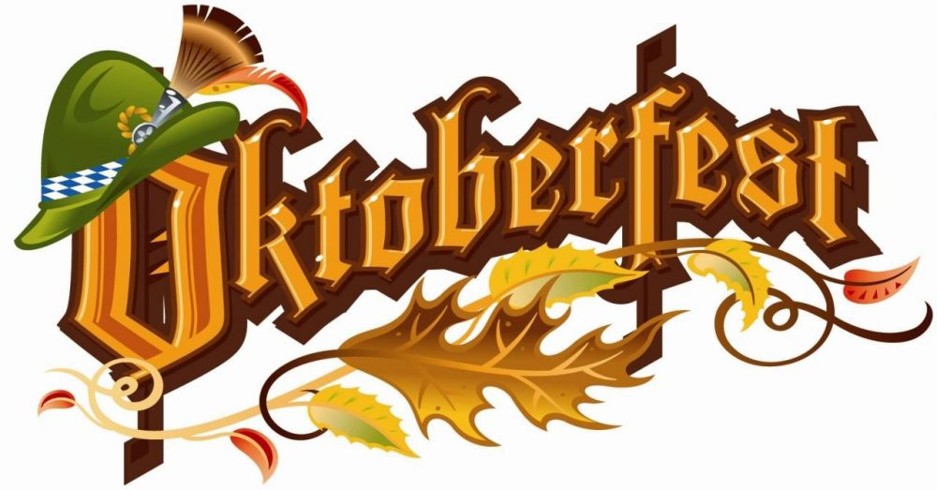


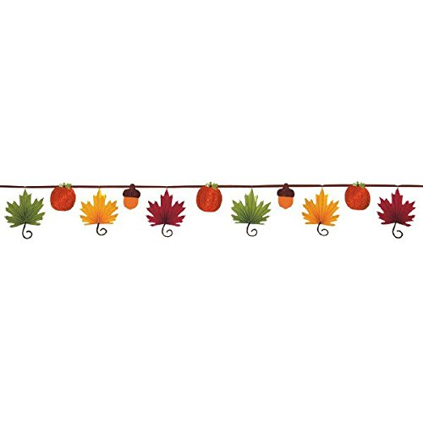
Saturday, October 31st from 5-7pm

Trunk or Treat will be on Halloween night, Saturday, October 31st. This is a huge event, and we usually get around 400 kids and their families coming through our parking lot. An excellent opportunity to share our message with the community! The event will begin at 5:00pm so we will need to set up and be ready to go by then. Look for more details in the announcements as we get closer to the event. There will be a sign up sheet for volunteers in the hallway starting October 1st. If you have questions, please contact Barbara Campbell at 317-445-3294 or call the church office.

Mark your calendars NOW so you don’t forget! OCTOBERFEST is coming on Friday, September 25 from 5:30-7:30. Invite a friend to join you! We will have brats and hot dogs on the grill, German potato salad, and all the usual goodies. We will also have some activities to do.
This will be paid for by Thrivent money.

THIS IS A FREE EVENT! SEE YOU THERE!

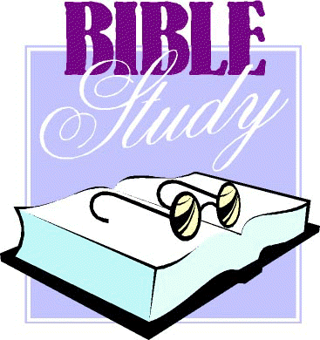

PARISH PLANNING MEETINGS are held the 2nd Tuesday of every month (Sept. 8/Oct 13) at 6pm. The business of the church is conducted at these meetings and any church member is welcome to attend, to ask questions, express concerns, make comments, etc.. Please let the Church office know the day before that you will be attending. 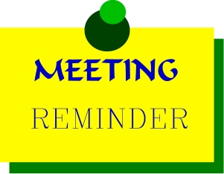
EMMAUS BIBLE STUDY CLASSES
FOR ALL AGES

Sunday Mornings
Sunday School 8:45am
Led by Pastor Gramzow

Women’s Bible Study
Our group meets on the 2nd and 4th Mondays of each month in the conference room. If you have any questions, please contact Barbara Campbell at 317-445-3294 or call the church office.

Senior Bible Study
The Senior Bible study is held on Wednesday’s starting at 9:30am. We meet in the room off the kitchen. Pastor Gramzow will begin leading our study when we return in September. We have some really interesting discussions. New members are always welcome to join.



CONTACT INFORMATION
Phone: 317-632-1486
Fax: 317-632-2620
Email:emmauschurchindy@gmail.com (church)
Website: www.elcindy.org
Facebook: www.facebook.com/emmausfountainsqaure
Bible Study
Thursday evenings from 7-8 p.m. In the room off the kitchen. Pastor Gramzow will begin a new study September 10th

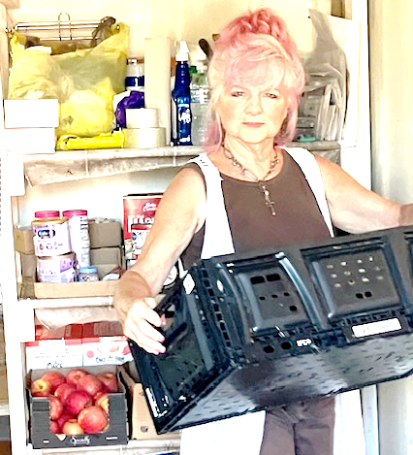

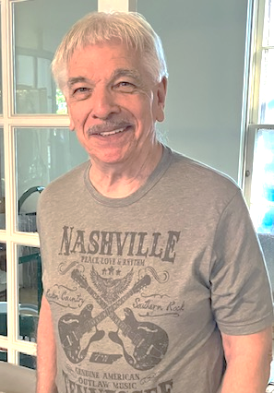
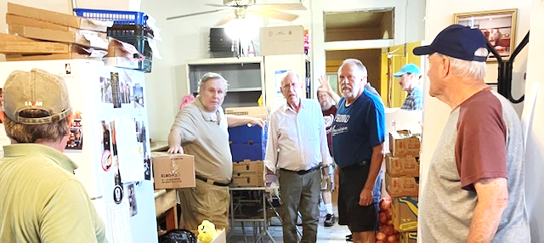
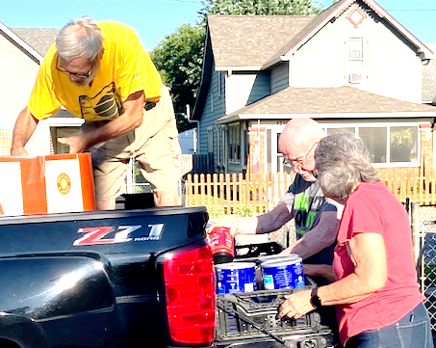
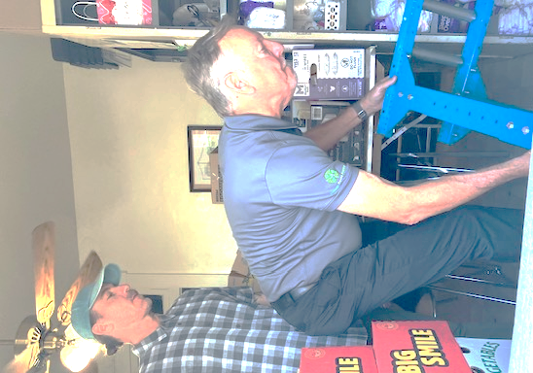
Some of our Monday Pantry volunteers helping unload the Gleaners truck!




September 2026 SCHEDULE

9/6 Jeff Frownfelter 9/6 Norm Riemer
9/13 Gary Strakis 9/13 Garald Evans
9/20 Bob Groth 9/20 Jerry Campbell 9/27 Tim Birtchman 9/27 Dave Duncan

9/6 Horst Hildebrandt 9/6 Cantwell/Smith
9/13 Roesener 9/13 The Frownfelter’s
9/20 Bob Groth 9/20 The Riemer’s
9/27 Carol Chandler 9/27 Whitsit/Herndon

Birtchman 
September Birthdays

Madeline Koch 9/1 Ellwyn Parks 9/15
Dave Duncan 9/10 Sandie Schultz 9/16
Barbara Campbell 9/12 Gary Strakis 9/21 Robin Westphal 9/12 Monica McNabney 9/26
Rosetta Cantwell 9/15






October 2026 SCHEDULE

10/4 Jeff Frownfelter 10/4 Norm Riemer
10/11 Gary Strakis 10/11 Garald Evans
10/18 Tim Birtchman 10/18 Jerry Campbell
10/25 Bob Groth 10/25 Dave Duncan

10/4 Kathy Rogers 10/4 Cantwell/Smith
10/11 Horst Hildebrandt 10/11 The Frownfelter’s
10/18 Roesener 10/18 The Riemer’s 10/25 Carol Chandler 10/25 Whitsit/Herndon

Frownfelter

October Birthdays

Sherry Jett 10/3 Laura Smallwood 10/18
Horst Hildebrandt 10/8 Karen Alter 10/25
Dottie Kemp 10/12 Timothy Birtchman 10/27

